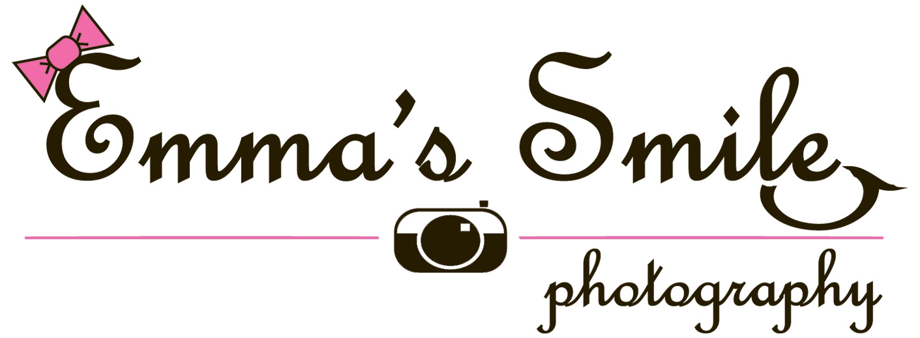
(252) 378-5302 erh110209@gmail.com

Wedding Photography Packages

Complete Wedding Package #1: $975

Engagement Session:
*30 minute session at the location of your choice
* DVD with high-resolution, fully edited images with copyright release
*(1) 8x10 print, (2) 5x7 prints, and (5) 4x6 prints

Bridal Portrait Session:
*60 minutes of photography at an outdoor location of your choice
* DVD with high-resolution, fully edited images with copyright release
*(1) 11x14 print

Wedding Day Coverage:
*Up to 3 hours of wedding day coverage including before, during, and after the ceremony.
*DVD with high-resolution, fully edited images with copyright release

Complete Wedding Package #2: $1550

Engagement Session:
*45 - 60 minutes session at up to two locations of your choice
* DVD with high-resolution, fully edited images with copyright release
*(1) 8x10 print, (2) 5x7 prints, and (5) 4x6 prints

Bridal Portrait Session:
*30 - 45 minutes of photography at an outdoor location of your choice
*30 – 45 minutes of photography at a second location of your choice
* DVD with high-resolution, fully edited images with copyright release
*(1) 11x14 print

Wedding Day Coverage:
*Up to 4 hours of wedding day coverage
*DVD with high-resolution, fully edited images with copyright release

COMPLEMENTARY Personalized Memory DVD of all images with music from wedding…

Complete Wedding Package #3: $2350

Engagement Session:
*45 - 60 minutes session at up to two locations of your choice
* DVD with high-resolution, fully edited images with copyright release
*(1) 8x10 print and (2) 5x7 prints
*(25) 4x6 Personalized “Save the Date” cards with the image(s) of your choice.

Bridal Portrait Session:
*30 - 45 minutes of photography at an outdoor location of your choice
*30 – 45 minutes of photography at a second location of your choice
* DVD with high-resolution, fully edited images with copyright release
*(1) 16x20 print, (1) 11x14 print, and (2) 8x10 prints

Wedding Day Coverage:
*Up to 6 hours of wedding day coverage including everything from getting ready before the wedding through the reception after the wedding.
*DVD with high-resolution, fully edited images with copyright release

Extras include:
*Personalized Memory DVD of all images
*12x12 Personalized Photo Book
*(2) 8x8 Personalized Parent Photo Books
*(25) 4x6 Personalized Thank You Cards with the image(s) of your choice

*$200 due at the Engagement Session to hold the wedding date; $200 due at the Bridal Portrait Session; The remaining balance is due 1 month prior to the wedding.

